A Major Project Report On

INTELLIGENT DDoS DETECTION & ADAPTIVE DEFENSE SYSTEM

Submitted in partial fulfilment of the Requirements for the award of the degree

BACHELOR OF TECHNOLOGY IN
INFORMATION TECHNOLGY

Submitted By

Routhu Sheshivarun
Adirepalli Yeshwanth
Madhav Konda
22EG112D57
22EG112D01
22EG112D39

Under the guidance of Mr. Mahesh Kumar Swamy
Assistant Professor



Department of Information Technology
ANURAG UNIVERSITY

(Approved by AICTE and NBA Accredited)
Venkatapur (V), Ghatkesar (M), Medchal district, Hyderabad, Telangana,500088

2022-2026

ANURAG UNIVERSITY

(Approved by AICTE and NBA Accredited)
Venkatapur (V), Ghatkesar (M), Medchal district, Hyderabad, Telangana,500088 Department of Information Technology


CERTIFICATE

This is to certify that the project report entitled “Intelligent DDoS Detection & Adaptive Defense System” is a Bonafide work done and submitted by Adirepalli Yeshwanth Reddy (22EG112D01), Routhu Sheshivarun (22EG112D13), Madhav Konda(22EG112D17) in partial fulfilment of the requirements for the award of the degree of B. Tech in Information Technology from Anurag University, Hyderabad during the academic year 2025-2026 and the Bonafide work has not been submitted elsewhere for the award of any other degree.

Internal Guide
Mr. Mahesh Kumar Swamy
Assistant Professor
H.O. D

Dr. Niteesha Sharma
Assistant Professor

External Examiner

ACKNOWLEDGEMENT

We would like to express our profound sense of gratitude to all for having helped us in completing this dissertation. We would like to express our deep-felt gratitude and sincere thanks to our guide Mr.Mahesh Kumar Swamy, Assistant Professor of Information Technology, of Anurag University, Ghatkesar, for his skillful guidance, timely suggestions and encouragement in completing this project.

We would like to express our sincere thanks to Dr. Niteesha Sharma, Head of the Department of Information Technology, Anurag University, Ghatkesar, whose motivation in the field of software development has made us to overcome all hardships during the course of study and successful completion of project.

We extend our sincere thanks to Dr. V. Vijaya Kumar, Dean, School of Engineering, and Dr. K.S.Reddy, Dean, Academics and Planning of Anurag University, Venkatapur(V), Ghatkesar(M), R.R. Dist, for their encouragement and constant help. Finally, we would like to express our heartfelt thanks to our parents who were very supportive both financially and mentally and for their encouragement to achieve our set goals.

Adirepalli Yeshawanth Reddy
Routhu Sheshivarun
Madhav Konda
(22EG112D01) (22EG112D57) (22EG112D39)

DECLARATION

This is to Certify that the project work entitled “Intelligent DDoS Detection & Adaptive Defense System” submitted to Anurag University in partial fulfilment of the requirement for the award of the Degree of Bachelor of Technology (B-Tech), is an original work carried out by Adirepalli Yeshwanth Reddy (22EG112D01), Routhu Sheshivarun(22EG112D13) and Madhav Konda(22EG112D39) under the guidance of Mr. Mahesh Kumar Swamy. This matter embodied in this project is a genuine work, done by the students and has not been submitted whether the university or to any other university/Institute for the fulfillment of the requirement of any course of study.

Adirepalli Yeshawanth Reddy
Routhu Sheshivarun
Madhav Konda
(22EG112D01) (22EG112D57) (22EG112D39)

ABSTRACT

Distributed Denial of Service (DDoS) attacks remain one of the most persistent threats to cloud availability, often bypassing traditional perimeter defenses through sophisticated application-layer patterns. This project presents an Intelligent DDoS Detection and Adaptive Defense System that integrates Machine Learning with real-time traffic orchestration to detect and mitigate HTTP flood attacks. The system employs a hybrid architecture combining rule-based thresholds for instantaneous response and a Random Forest Classifier for deep behavioral pattern recognition.

The core of the system is an Adaptive Defense Engine that dynamically transitions between three operational states: Normal, Attack, and Cooldown. Unlike static firewalls, this system adjusts rate-limiting thresholds and blocking durations (ranging from 30s to 300s) based on threat confidence levels provided by the ML service. The model was trained on the CIC-DDoS2019 dataset, utilizing 4,313 labeled samples and a refined set of 13 behavioral features—including traffic concentration, relative entropy of source IPs, and latency variances—to distinguish between legitimate flash crowds and malicious botnet activity.

The implementation features a high-performance FastAPI backend for asynchronous traffic monitoring and a React-based real-time dashboard for live telemetry and threat visualization. Deployed within a containerized Docker environment for seamless cloud scalability on AWS, the system achieved a 98.03% test accuracy with a precision of 98.6%. This project demonstrates a production-ready approach to cybersecurity, offering a low-latency, self-healing defense mechanism that ensures 99.9% service availability even under active application-layer assault.

CONTENTS

CHAPTERS PAGE NO

List of Figures

List of Tables

List of Abbreviations
- INTRODUCTION
  - Overview
  - Objectives
  - Problem Formulation
  - Scope of the Project
  - Feasibility
  - Requirements of the Project
    - Software Requirements
    - Hardware Requirements
- REQUIREMENTS
  - Requirements
    - Functional Requirements
    - Non-Functional Requirements
- ANALYSIS
  - UseCase Model
    - Use Case Diagram
  - Flow of Events
    - Flow of events Diagram
  - Activity Diagram
3.2.1 Activity Diagram
- DESIGN
  - E-R diagram 4.2 Class diagram
  - Sequence diagram
  - System Architecture
vii ix

x

1
1
2
2
3

4
4

5
6
9

10
11
13
15
16
16

18
20
25
27

- IMPLEMENTATION
  - ProjectOverview 30
  - Tech Stack 31
  - Project Implementation 35
  - Performance Evaluation 52
- USER SCREEN
  - UserHomeScreens 54
- TESTING METHODOLOGIES 61
  - Test cases table 61
- CONCLUSION & FUTURE WORK
  - Conclusion 65
  - Future Enhancements 65
- REFERENCES 68

LIST OF FIGURES
Figure Number

3.1.1

3.2.1

3.3.1

4.1.1

4.2.1

4.3.1

4.4.1

6.1

6.2

6.3

6.4

6.5

6.6

6.7
Name of Figure

Use Case Diagram Flow of Events Diagram
Activity Diagram E – R Diagram Class Diagram Sequence Diagram
System Architecture

Analysis Settings and Image Upload Interface

Classification Probability Distribution and Detailed Result

Grad-CAM Interpretability Analysis System Performance Metrics Display Uncertain Case Review Interface Generated Prediction Report
System Overview Dashboard
Page No

11

15

16

19

24

25

27

54

55

56

57

58

59

60

LIST OF ABBREVIATIONS
S.no

1

2

3

4

5

6

7

8

9

10
Abbreviation

AI

ML

DL

CNN

ROI

VGG

ResNet

ROC

AUC

Grad-CAM
Full Form

Artificial Intelligence

Machine Learning

Deep Learning

Convolutional Neural Network

Region of Interest

Visual Geometry Group Network

Residual Network

Receiver Operating Characteristic

Area Under Curve

Gradient-weighted Class Activation Mapping

LIST OF TABLES
Table No.

1
Title

Test Cases for Personality Classification System
Page No.

64

- INTRODUCTION

Overview

The Intelligent DDoS Detection & Adaptive Defense System is a sophisticated cybersecurity framework designed to safeguard cloud-hosted web applications from application-layer Distributed Denial of Service (DDoS) attacks. As modern cyber threats evolve beyond simple volumetric floods, this system utilizes a Hybrid Detection Architecture that integrates machine learning behavioral analysis with real-time traffic orchestration. The system operates by intercepting incoming HTTP traffic and extracting granular behavioral telemetry to distinguish between legitimate user spikes and coordinated botnet activity.
At its core, the system utilizes a Random Forest Classifier as a high-accuracy detection engine, trained on the comprehensive CIC-DDoS2019 dataset. To ensure a balance between security and performance, the architecture implements a Tri-State Adaptive Defense Engine (Normal, Attack, and Cooldown modes). When the ML service identifies a threat with high confidence, the system automatically transitions into an aggressive defense posture, tightening rate limits and extending block durations for suspicious IPs. The entire framework is built using an asynchronous FastAPI backend for low-latency processing and a React-based dashboard for real-time threat visualization and monitoring. By containerizing the ML components with Docker, the system provides a scalable, platform-agnostic solution for modern cloud infrastructure.

Objective

The primary objective of the Intelligent DDoS Detection & Adaptive Defense System is to develop a self-healing security mechanism that can autonomously identify and mitigate sophisticated HTTP flood attacks in real-time. The system aims to move beyond static, rule-based firewalls by incorporating Behavioral Machine Learning, allowing for a more nuanced understanding of traffic patterns and reducing the risk of blocking legitimate users during "flash crowd" events.

Another key objective is the implementation of Dynamic Response Scaling, where the system’s defense strength is directly proportional to the detected threat level. This ensures that resources are protected during peak attacks while maintaining a seamless user experience during periods of low threat. Additionally, the project focuses on providing Operational Transparency through a real-time dashboard, enabling security administrators to visualize traffic metrics, top attacking IPs, and ML confidence scores. Overall, the project aims to deliver a production-ready, interpretable, and automated solution for DDoS mitigation, contributing to the field of AI-driven proactive cybersecurity.

Problem Formulation
Modern web services face an increasing threat from application-layer DDoS attacks, which mimic legitimate user behavior to exhaust server resources. Traditional security measures often rely on static, volumetric thresholds that are easily bypassed by sophisticated "low and slow" attacks or distributed botnets. Manual intervention to update firewall rules is a time-consuming process that often leads to significant downtime during an active assault, causing financial and reputational loss.
Existing automated defense systems frequently suffer from high False Positive rates, where legitimate "flash crowds" (sudden spikes in real user traffic) are mistakenly blocked, hurting the business. Furthermore, many signature-based detection systems fail to recognize zero-day attack patterns that do not match known historical threats. Another challenge is the high computational overhead and latency introduced by deep-packet inspection, which can slow down legitimate traffic even when no attack is present.
Therefore, there is a need for an intelligent system that can distinguish between malicious patterns and legitimate traffic spikes with high precision and minimal latency. The proposed system addresses these challenges by implementing a Machine Learning-driven Behavioral Analysis engine, a Tri-State Adaptive Defense mechanism to reduce false positives, and an asynchronous architecture that ensures real-time detection without compromising the performance of the protected web service.

Scope
The Intelligent DDoS Detection & Adaptive Defense System focuses on the automated identification and mitigation of application-layer (Layer 7) HTTP flood attacks. The system processes real-time network telemetry, extracts behavioral features using machine learning techniques, and executes adaptive response strategies to maintain web service availability.

The scope of the project includes real-time traffic monitoring, feature extraction of 13 key behavioral metrics (such as RPS, traffic concentration, and latency), and the deployment of a Random Forest Classifier trained on the CIC-DDoS2019 dataset. It also encompasses the development of an Adaptive Defense Engine capable of transitioning between Normal, Attack, and Cooldown states, as well as a centralized React-based dashboard for live monitoring and performance visualization.
The system is currently optimized for cloud-based web services and operates on containerized microservices using Docker. While the current implementation is focused on HTTP-based DDoS patterns, the architecture is designed to be modular and scalable, allowing for future integration of additional attack vectors (such as TCP/UDP floods), deep learning models (like LSTMs for sequence analysis), and multi-node cluster support for large-scale enterprise environments.

Feasibility

The Intelligent DDoS Detection & Adaptive Defense System is highly feasible from technical, operational, and economic perspectives, ensuring its viability as a production-ready security solution.
Technically, the system is implemented using Python 3.11 and high-performance libraries such as FastAPI, Scikit-learn, Pandas, and NumPy. These tools provide the necessary asynchronous capabilities and mathematical precision required for real-time traffic analysis. The use of a Random Forest classifier ensures high detection accuracy without the extreme computational overhead of deep neural networks, allowing the ML service to run efficiently within Docker containers on standard cloud instances like AWS EC2.
Operationally, the system adopts a Microservices Architecture, where the traffic monitoring backend, the ML prediction engine, and the React frontend function as independent yet interconnected modules. This modularity ensures that the defense mechanism can be updated or scaled without disrupting the core web service. The automated state minimize the need for manual intervention, making it operationally efficient for small-to-medium enterprise environments.
Economically, the project is exceptionally cost-effective. It is built entirely on open-source technologies and utilizes the publicly available CIC-DDoS2019 dataset for training, eliminating licensing costs. By preventing server downtime and optimizing resource usage through adaptive rate-limiting, the system provides significant long-term financial value by protecting the underlying infrastructure from costly service interruptions.

System Requirements

Software Requirements

Programming & Development Environment

- Programming Language: Python 3.11
- Development Environment: VS Code
- Containerization: Docker

Machine Learning & Data Processing

- ML Framework: Scikit-learn
- Data Handling: Pandas, NumPy
- Data Source: CIC-DDoS2019 Dataset

Backend & API Layer

- Web Framework: FastAP Data Handling
- Server: Uvicorn (ASGI server implementation)
- Traffic Tracking: Custom Python

Frontend & Visualization

- Web Library: React.js
- API Client: Axios (for backend communication)

Deployment & Infrastructure

- Cloud Platform: AWS EC2
- Operating System: Linux (Ubuntu 22.04) or Windows 10/11

Hardware Requirements
      - Processor: Intel Core i5 (10th Gen or higher) or AMD Ryzen 5
      - RAM: 8 GB (Minimum), 16 GB (Recommended for running Docker + Frontend simultaneously)
      - Storage: 20 GB free space (for Docker images and dataset samples)

REQUIREMENTS

Requirements Specification
The requirements specification defines the functional and non-functional capabilities of the Intelligent DDoS Detection & Adaptive Defense System. These requirements describe how the system monitors network traffic, extracts behavioral features, executes machine learning predictions, and orchestrates defense mechanisms. The system is designed to provide real-time protection for web services by distinguishing between legitimate traffic spikes and malicious HTTP flood patterns, ensuring high availability through an automated state-machine response.

Functional Requirements

Traffic Monitoring & Interception Module.

Dataset Handling and Splitting
- The system shall intercept all incoming HTTP requests in real-time.
- The system shall log request metadata, including Source IP, Timestamp, and Request Path.
- The system shall maintain an active count of Requests Per Second (RPS) per IP address.

Feature Extraction Module
    - The system shall extract 13 key behavioral features every 5 seconds.
    - The system shall calculate statistical metrics including Total RPS, Unique IP count, and average latency.
    - The system shall compute traffic concentration ratios (e.g., Top IP percentage) to identify botnet signatures.

Machine Learning Prediction Module
- The system shall transmit extracted feature vectors to the Random Forest model service.
- The system shall generate a prediction output consisting of is_attack (boolean), confidence (percentage), and threat_level (low to critical).
- The system shall support asynchronous inference to prevent blocking legitimate traffic flows.

Adaptive Defense Engine (State Machine)
- The system shall implement three distinct operational modes: Normal, Attack, and Cooldown.
- The system shall automatically transition to Attack Mode if ML confidence exceeds 70%.
- The system shall execute a Cooldown Mode for a defined period (e.g., 60s) before returning to Normal status to prevent immediate re-attacks.

Rate Limiting & Blocking Module
    - The system shall enforce dynamic rate limits based on the current defense mode (20 RPS in Normal vs. 10 RPS in Attack.
    - The system shall automatically block IPs exceeding the "Block Threshold" using a temporary blacklist.
    - The system shall return an HTTP 429 (Too Many Requests) status code to throttled or blocked users.

Automated Recovery Module
    - The system shall implement a "Self-Healing" timer that restores Normal thresholds after 5 minutes of clean traffic.
    - The system shall automatically clear expired IP blocks from the memory cache.

7. Real-Time Monitoring Interface (Frontend)
    - The system shall provide a web-based dashboard using React.js.
    - The system shall display live line charts for Traffic Volume and RPS.
    - The system shall provide a "Threat Status" indicator (Green, Yellow, Red) updated every 2 seconds.

Logging & Analytics Module
    - The system shall maintain a table of "Top Attacking IPs" with their respective block status.
    - The system shall track defense statistics, including total blocked requests and throttled attempts.
    - The system shall provide visual feedback on ML model precision and recall during active sessions.

Deployment & Orchestration
- The system shall utilize Docker to containerize the ML prediction service for environment consistency.
- The system shall support deployment on AWS EC2 to simulate a cloud-hosted production environment.

Error Handling & User Feedback
- The system shall display clear loading states during ML initialization.
- The system shall provide alerts on the dashboard when a transition to "Attack Mode" occurs.
- The system shall ensure that legitimate user sessions are maintained with minimal latency during defense transitions

Feature Caching & Persistence
- The system shall store extracted traffic features in a temporal buffer to allow for historical trend analysis.
- The system shall allow for the export of captured attack features as CSV or JSON for offline model re-training.

Performance Dashboard & Analytics
- The system shall provide visual analytics using Recharts to display real-time traffic volume
- The system shall show a distribution of "Attack vs. Normal" traffic as a percentage to evaluate the current threat landscape.

Multi-Threshold Rate Limiting

- The system shall implement differentiated rate limits for different defense modes (e.g., 20 RPS for Normal, 15 RPS for Cooldown, and 10 RPS for Attack).

Reporting & Audit Logging

- The system should generate downloadable PDF reports for predictions.
- The report should include prediction results, confidence scores, and visualizations.

Responsive User Interface
- The system should provide a responsive web interface using Streamlit.
- The system should support access across different devices.

User Interaction Feedback

- The system should display loading indicators during processing.
- The system should provide error messages for invalid inputs.
- The system should give feedback for successful predictions.

Non-Functional Requirements

Performance
    - The system shall process incoming HTTP requests and execute ML inference within a low-latency window (5-10 seconds) to ensure real-time defense.
    - The asynchronous nature of FastAPI shall ensure that the traffic monitoring process does not bottleneck the overall application performance.
    - The system shall ensure efficient execution on standard cloud instances (CPU-based) without requiring specialized hardware acceleration

Scalability
      - The microservices architecture shall support the independent scaling of the ML prediction service and the traffic monitoring backend.
      - The system shall be designed to handle increasing traffic volumes by deploying additional Docker containers behind a load balancer.
        - Future enhancements, such as Deep Learning models (LSTMs or Transformers) or support for new attack vectors, should be easily incorporable into the modular framework

Reliability

        - The system shall provide consistent and accurate detection (targeting 98%+ accuracy) to maintain the integrity of the security perimeter.
        - The system shall handle connection timeouts or ML service unavailability gracefully by defaulting to a safe, rule-based rate-limiting mode.

Usability
      - The React-based dashboard shall provide a simple and intuitive interface for security administrators to monitor live traffic.
      - Threat levels and system states (Normal/Attack/Cooldown) shall be clearly color-coded for instant interpretation by both technical and non-technical users.

Portability

      - The system shall be fully containerized using Docker, ensuring it runs consistently across Windows, Linux, and Cloud environments (AWS/Azure).
      - The backend shall be compatible with standard Python 3.11 environments and common IDEs like VS Code.

Security
    - The system shall ensure that the internal monitoring logs and blacklisted IP data are protected from unauthorized external access
    - Communication between the frontend, backend, and ML service shall be restricted to secure internal network protocols or encrypted channels.

Maintainability
- The system shall follow a modular design where the ML logic, API endpoints, and UI components are decoupled for easy updates and debugging
- Comprehensive logging of all attack detections and state changes shall be maintained to facilitate post-mortem analysis and system auditing.

ANALYSIS

Use case model

A Use Case Model represents how actors interact with the Intelligent DDoS Detection & Adaptive Defense System and defines the functional behavior of the system. This model illustrates the interaction between the system administrator and the underlying automated modules to monitor network traffic, detect malicious patterns using Machine Learning, and execute adaptive defense strategies.
The system integrates real-time traffic interception, feature engineering, ML-based classification (Random Forest), and a tiered response mechanism into a unified security framework. The primary actors in this system are the System Administrator and the Automated Security Engine

Main Use Cases
- Real-Time Traffic Monitoring: The system continuously captures and logs incoming HTTP request metadata.
- Behavioral Feature Extraction: Calculation of 13 key metrics (RPS, Latency, Concentration) every 5 seconds.
- Attack Prediction (ML Inference): The ML service classifies current traffic patterns as "Normal" or "Attack" with a specific confidence score.
- Security Dashboard Visualization: Real-time display of traffic graphs, attack logs, and system health status.

Launch DDoS Attack & Blocking
The Attacker initiates high-volume malicious traffic. The system identifies this behavior, leading to the attacker being automatically Blocked, receiving an HTTP 429 (Too Many Requests) response to neutralize the threat.

Send HTTP Request & Monitoring
The Normal User sends standard web requests. The system acts as a transparent proxy, continuously Monitoring these requests to distinguish legitimate traffic from potential attack patterns without interrupting the user experience.

Detect Attack Pattern
This is the core analytical process where the system evaluates incoming traffic streams. It serves as the entry point for the intelligent defense pipeline, triggered whenever traffic deviates from established baselines.

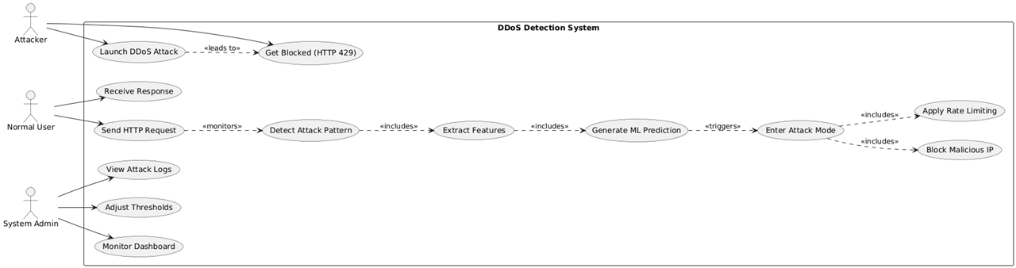

Fig 3.1.1 Use Case Diagram

Feature Extraction
The system processes monitored data to extract 13 behavioral features (such as RPS, unique IP count, and traffic concentration). This transforms raw network packets into a structured mathematical format suitable for machine learning analysis.

Generate ML Prediction
When an attack is detected with high confidence, the system triggers the Attack Mode. This state transition changes the system's defensive posture from lenient to aggressive to protect the server infrastructure.

Rate Limiting & IP Blocking
Once in Attack Mode, the system executes two primary defense mechanisms:
- Apply Rate Limiting: Throttles suspicious traffic by lowering the allowed Requests Per Second (RPS).
- Block Malicious IP: Completely blacklists confirmed attacking IP addresses for a set duration (e.g., 300 seconds).

Enter Attack Mode
When an attack is detected with high confidence, the system triggers the Attack Mode. This state transition changes the system's defensive posture from lenient to aggressive to protect the server infrastructure.
Relationships
Includes:
      - Detect Attack Pattern includes Extract Features.
      - Extract Features includes Generate ML Prediction.
      - Enter Attack Mode includes Apply Rate Limiting and Block Malicious IP.
Triggers:
- Generate ML Prediction triggers the transition to Enter Attack Mode based on confidence levels.

Generalization:
- Attacker: Interacts only with the attack and blocking boundary.
- Normal User: Interacts with the request and response cycle.

Flow of Events
The system follows a high-speed, structured workflow to monitor network traffic, identify threats, and apply adaptive defense measures in real-time.

Steps Involved:
Traffic Interception
The user (or attacker) sends an HTTP request. The Backend System (FastAPI) intercepts the request metadata immediately.

Telemetry Logging
The system logs the request details and updates the per-IP statistics (Request count, timestamps) in the memory cache.

Attack Prediction
The Random Forest Model processes the features and returns a prediction (is_attack), a confidence score, and a threat level.

Mode Transition (State Machine)
The Defense Engine evaluates the prediction. If confidence is high, it triggers the transition from Normal to Attack Mode.

Adaptive Defense Execution
The system dynamically updates its rate limits and identifies specific IPs for blocking based on the new mode's aggressive thresholds.

Real-Time Visualization
The updated system status, attack metrics, and blocked IP lists are pushed to the Frontend Dashboard.

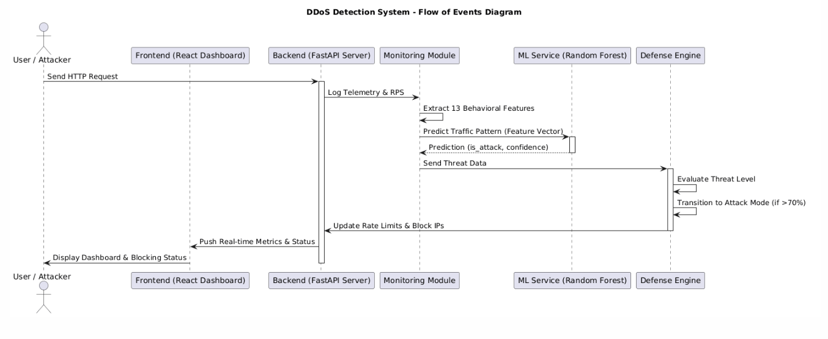

Output & Feedback
The system displays the current security posture (Green/Yellow/Red) and logs the incident for the System Admin to review.

Activity Diagram
Activity diagrams represent the workflow of the system and the sequence of operations performed during real-time traffic monitoring and DDoS mitigation. The process begins when the system receives an HTTP request and simultaneously runs a background machine learning analysis loop.

Receive HTTP Request
The system intercepts incoming traffic and splits the workflow into two parallel paths: the Request Handling Path and the Background ML Loop.
Traffic Filtering & Validation
On the request path, the system extracts the Client IP and checks it against the current Blacklist. If the IP is blocked, it returns an HTTP 429 error; otherwise, it proceeds to check the Requests Per Second (RPS) against current thresholds.

Feature Extraction
Within the background loop (running every 5 seconds), the system gathers 13 behavioral features from the accumulated traffic telemetry to prepare for analysis.

ML Prediction & Decision

The system queries the ML Service. If the service is available, it retrieves a prediction. A decision node checks if is_attack = true AND confidence > 70%.

Attack Mode Execution
If an attack is confirmed, the system enters ATTACK MODE. It performs three actions in parallel:
      - Blocking suspicious IPs.
      - Lowering rate limits.
      - Increasing block durations. A 5-minute cooldown timer is then initiated.

Auto-Recovery & Normalization

If no attack is detected or the timer expires, the system checks if it is currently in Attack Mode. If so, it triggers the recovery sequence:
Returning to NORMAL MODE, restoring lenient thresholds, and clearing the suspicious IP list.

Result Generation
For every legitimate request processed, the system records statistics and returns an HTTP 200 OK response. The background loop continues as long as the system is running.

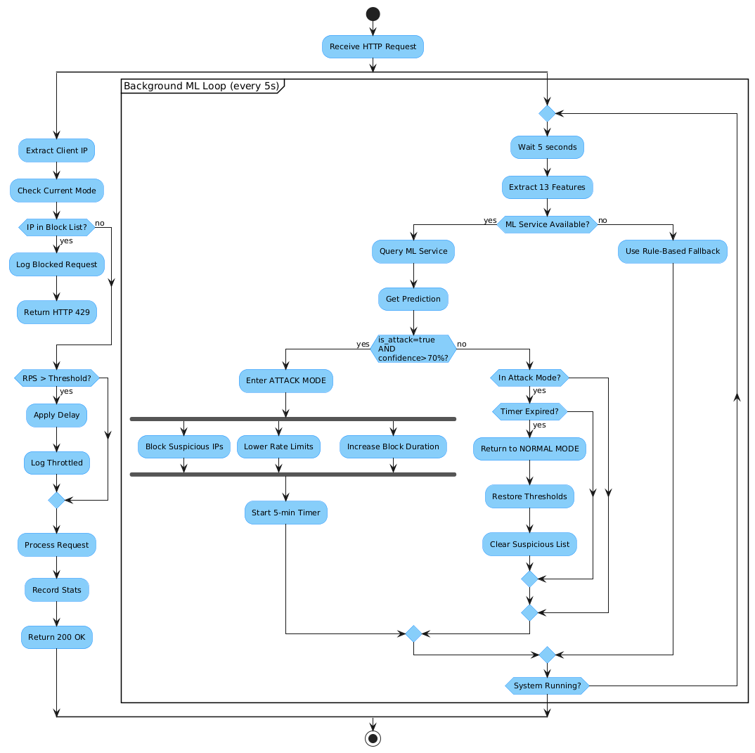

Fig 3.3.1 Activity Diagram

DESIGN

E-R Diagram
The Entity-Relationship (ER) Diagram represents the data structure of the Breast Cancer Detection System. It shows how different entities interact to support image processing, prediction generation, model usage, and reporting.The system integrates deep learning models with a structured database, enabling efficient storage, retrieval, and analysis of medical image data.

Fig 4.1.1 E-R Diagram
The Entity-Relationship (ER) Diagram for the Breast Cancer Detection System represents how different entities interact to support histopathology image processing, feature extraction, and cancer classification.

User Entity
Description:Represents the individual who interacts with the system (doctor/admin). Attributes:
user_id (Primary Key) name
email Relationship:
A User uploads multiple Images (One-to-Many)

Image Entity
Description:Represents the histopathology image uploaded by the user. Attributes:
image_id (Primary Key) file_path
upload_time format
Relationships:
Uploaded by User Generates Prediction
Can be flagged as Uncertain Case

Prediction Entity Description:
Stores the results generated by the AI model.

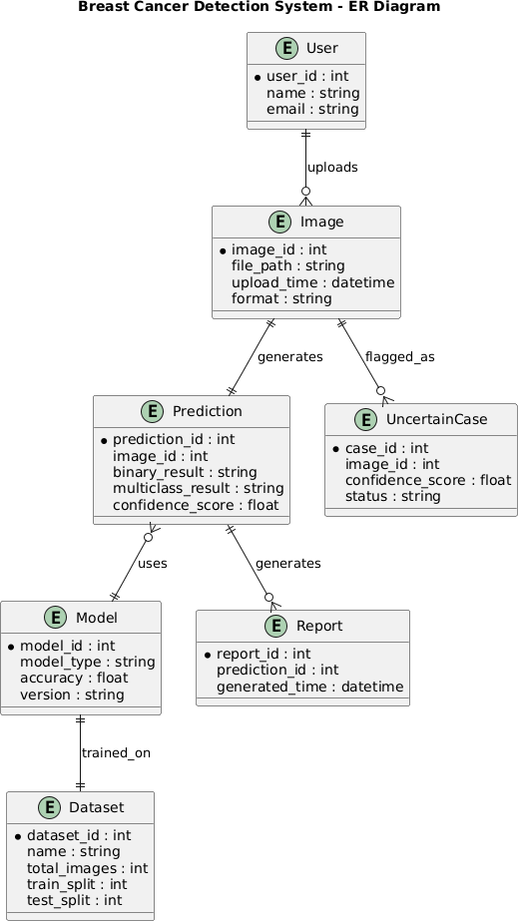

Fig 4.1.1 E-R Diagram

Attributes:
prediction_id (Primary Key) image_id (Foreign Key)
binary_result (Benign/Malignant)
multiclass_result (Subtype classification) confidence_score
Relationships:
Generated from Image Uses Model
Generates Report

Uncertain Case Entity Description:
Stores predictions with low confidence for review (Active Learning). Attributes:
case_id (Primary Key)
image_id (Foreign Key) confidence_score
status Relationship:
Derived from Image when prediction confidence is low This supports active learning improvement

Model Entity Description:
Represents the trained deep learning models used for prediction. Attributes:
model_id (Primary Key) model_type
accuracy version
Relationships: Used by Prediction Trained on Dataset

Report Entity Description:
Stores generated reports for predictions. Attributes:
report_id (Primary Key)
prediction_id (Foreign Key) generated_time
Relationship:
Generated from Prediction

Dataset Entity Description:
Represents the dataset used for training the models. Attributes:
dataset_id (Primary Key) name
total_images train_split
test_split Relationship:
Used to train the Model

Class Diagram
A Class Diagram describes the structure of the system by representing system classes, their attributes, methods, and the relationships between them.

User
Attributes:
user_id name
email Methods:
uploadImage() viewResults()

Role:
Represents the primary actor of the system who interacts with the breast cancer detection platform.
Relationships:
Owns one or more Images (1..*)
Can upload images and view prediction results

Image
Attributes:
image_id (PK) user_id (FK)
image_path upload_time format
Methods:
loadImage()
displayImage() Role:
Represents the histopathology image uploaded by the user for breast cancer detection. Responsibility:
Belongs to one User (1..1)
Generates features for classification
Used as input for preprocessing and model prediction

Preprocessor
Attributes:
image_size
normalization_type Methods:
resizeImage()
normalizeImage() Role:
Processes the input image before feeding it into the model. Responsibility:
Connected to Image
Prepares image for feature extraction

FeatureExtractor
Attributes:
model_name
feature_dimension

Methods:
extractFeatures() Role:
Extracts deep features from the preprocessed image using CNN-based architectures.
Responsibility:
Connected to Preprocessor
Provides features to BinaryModel and MulticlassModel

Model
Attributes:
model_id
model_type accuracy
version Methods:
buildModel() predict()
Role:
Computes prediction results using extracted features from the image.
Responsibility:
Uses FeatureExtractor
Provides output to Prediction

Prediction
Attributes:
prediction_id
image_id (FK) binary_result
multiclass_result confidence_score
Methods:
generatePrediction()
calculateConfidence() Role:
Represents the prediction results generated by the model for a given image.
Responsibility:
Stores classification results (binary and multiclass) Maintains confidence score of prediction
Provides output for report generation and analysis

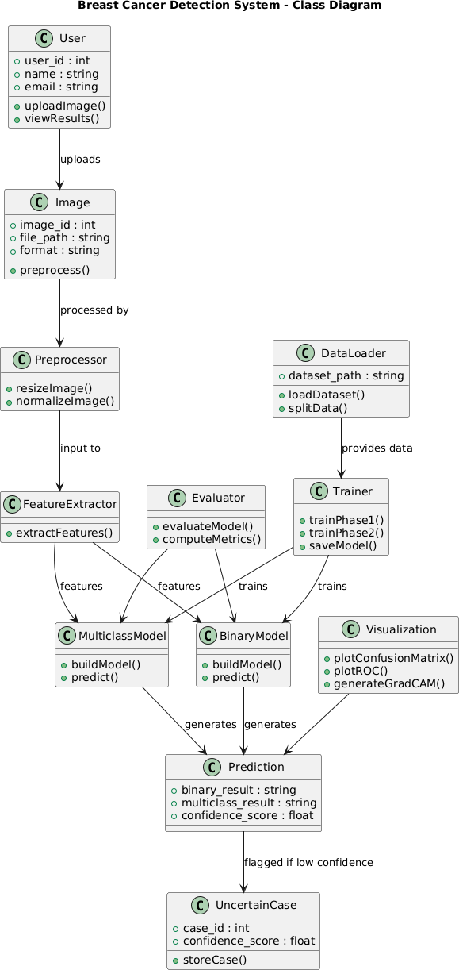

Fig 4.2.1 Class Diagram

Sequence Diagram
The Sequence Diagram illustrates how different components of the system interact over time to perform breast cancer detection using histopathology images. The diagram consists of three major components:
User Interface
Processing Module Data Storage
The User Interface allows users to upload histopathology images and view prediction results. The Processing Module performs image preprocessing, feature extraction, model prediction (binary and multiclass), and Grad-CAM visualization.
The Data Storage component stores images, prediction results, evaluation metrics, and uncertain cases for further analysis.

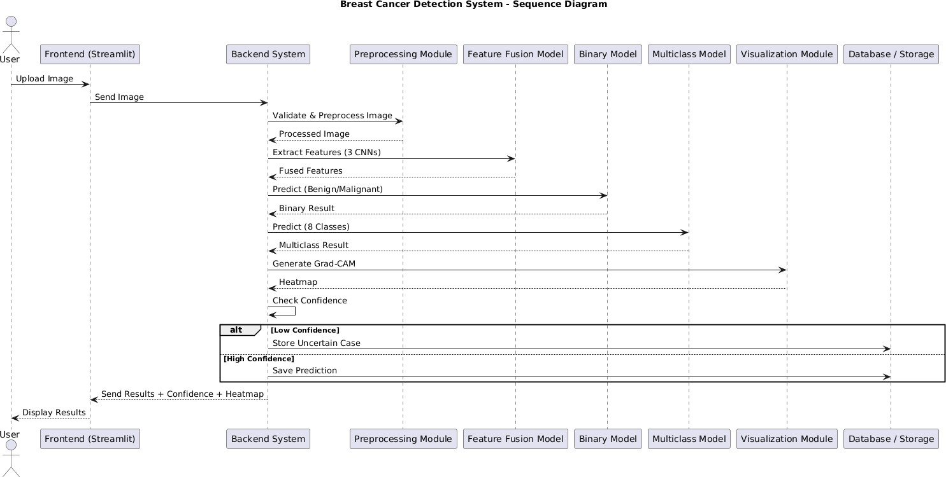

Fig 4.3.1 Sequence Diagram

Sequence of Operations Image Upload
The user uploads a histopathology image through the user interface.

Preprocessing
The system resizes and normalizes the image for model input.

Feature Extraction
Deep features are extracted from the image using CNN-based models.

Feature Fusion
Features from multiple models are combined into a unified feature vector.

Model Prediction
The fused features are passed into binary and multiclass models to generate predictions.

Uncertainty Evaluation
Confidence score and entropy are computed to evaluate prediction reliability.

Statistical Evaluation
ROC curves and AUC values are computed for model validation.

Result Display
The system presents the final prediction results, confidence scores, Grad-CAM visualization, and evaluation metrics to the user.

System Architecture
The Breast Cancer Detection System is designed as a modular architecture that integrates deep learning techniques and medical image analysis for cancer classification. The architecture consists of several major components that work together to analyze histopathology images and generate accurate and interpretable prediction results..

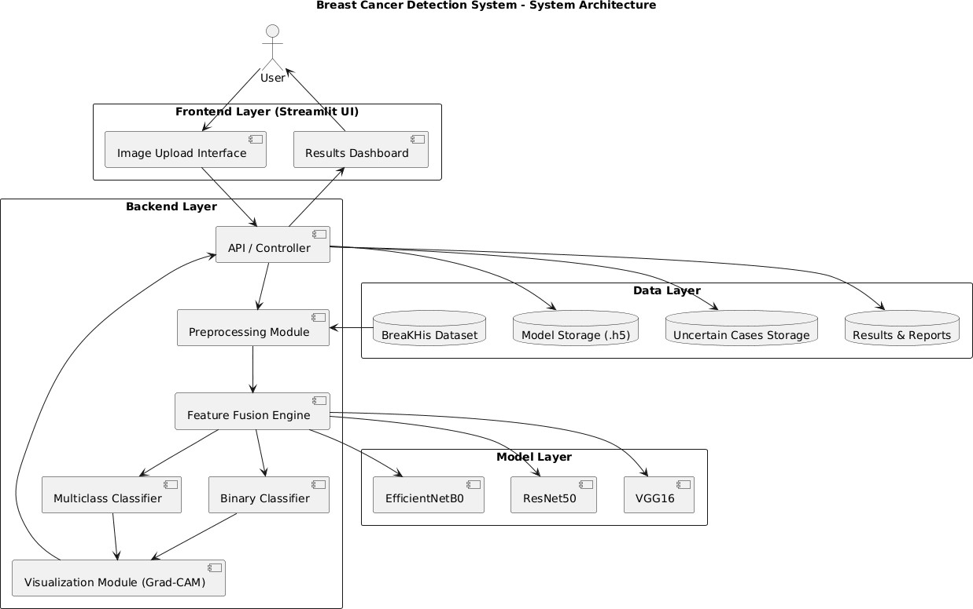

Fig 4.4.1 System Architecture

Image Input Module
This module accepts histopathology images provided by the user or dataset. The input images are preprocessed through resizing, normalization, and noise reduction to ensure consistent input quality.

Preprocessing Module
This module prepares the input image by resizing it to the required dimensions and normalizing pixel values. It ensures the image is suitable for deep learning models.

Feature Extraction Module
Using CNN-based architectures, the system extracts deep features from the preprocessed image. These features capture important patterns such as textures and cellular structures relevant for classification.

Feature Fusion Module
The extracted features from multiple models (EfficientNet, ResNet, VGG) are combined into a unified feature vector. This fusion improves the representation and overall model performance.

Prediction Module
The fused features are passed through binary and multiclass models to generate prediction results such as benign/malignant classification and cancer subtype detection.

Statistical Evaluation Module
The system evaluates the performance and reliability of the model using statistical techniques such as:
ROC Curve Analysis AUC Evaluation
Confusion Matrix Analysis
Accuracy, Precision, Recall, and F1-Score

Output Visualization Module
The final prediction results and evaluation metrics are presented through an interactive frontend interface developed using Streamlit. This module provides a user-friendly environment where users can view breast cancer classification results and visualizations generated by the system.
The Streamlit interface allows users to upload histopathology images, view prediction outcomes, and analyze classification results in a clear and structured format. The output dashboard displays predicted class (benign/malignant or subtype), confidence scores, and uncertainty measures.
Various visualization techniques are used to improve interpretability, including bar charts, probability distributions, Grad-CAM heatmaps, and statistical graphs that highlight the regions of the image influencing the prediction. The system may also display ROC curves and performance metrics to demonstrate the reliability of the model.
The frontend interface ensures that the results are presented in an intuitive, interactive, and easily understandable format, enabling users and medical professionals to interpret the system’s predictions effectively.

IMPLEMENTATION

Project Overview
The Breast Cancer Detection System is designed to analyze histopathological images and classify them into benign and malignant categories, as well as into specific cancer subtypes, using deep learning techniques. The system takes microscopic tissue images as input and processes them through a series of computational steps to generate accurate and interpretable predictions.
The implementation follows a structured pipeline that includes image preprocessing, feature extraction using multiple convolutional neural networks, feature fusion with attention mechanisms, model training, and final classification. The core of the system is a Feature Fusion Ensemble Architecture, where three pre-trained CNN models—EfficientNetB0, ResNet50, and VGG16—operate in parallel to extract complementary features from the same input image.
The extracted features are combined and refined using a Squeeze-and-Excitation (SE) attention block, which enhances the most relevant features for classification. The system performs both binary classification (benign vs. malignant) and multiclass classification across eight cancer subtypes.
To improve efficiency, a feature caching mechanism is implemented, where extracted features are stored and reused during training, significantly reducing computational time. The system also integrates an Active Learning module to identify uncertain predictions and a Grad-CAM module to provide visual explanations of model decisions.
The system is deployed using a Streamlit-based web interface, allowing users to upload images, view predictions, and generate reports.

Key Features
Histopathology image input and preprocessing
Multi-CNN feature extraction (EfficientNetB0, ResNet50, VGG16) Feature fusion with SE attention mechanism
Binary and multiclass classification Feature caching for fast training
Active Learning for uncertainty detection

Grad-CAM visualization for interpretability
Web-based interface for prediction and reporting

Technology Stack

Development Tools
IDE: VS Code / Jupyter Notebook Version Control: Git & GitHub

Programming Language
Python

Operating System
Windows / Linux

Libraries and Frameworks
TensorFlow / Keras – Deep learning model development OpenCV – Image processing and visualization
NumPy – Numerical computations and feature handling Pandas – Data management and logging
scikit-learn – Evaluation metrics and statistical analysis Matplotlib – Visualization of results
Streamlit – Web application development ReportLab – PDF report generation

Implementation Steps

Step 1: Dataset Collection
The first step involves collecting the BreaKHis v1 dataset, which contains 7,909 histopathological images across eight cancer subtypes. The dataset is organized into benign and malignant categories and further divided into training, validation, and test sets using stratified sampling to maintain class balance.

Step 2: Image Preprocessing
Before feeding images into the model, preprocessing is performed to ensure consistency and improve model performance. The preprocessing steps include:

Resizing images to 160×160 pixels Converting images to RGB format Normalizing pixel values
Preparing labels for binary and multiclass classification These steps help the model learn meaningful features efficiently. Step 3: Feature Extraction
In this step, the system extracts features using three pre-trained CNN models: EfficientNetB0
ResNet50 VGG16
Each model processes the input image independently and generates feature maps. Global Average Pooling is applied to convert these feature maps into fixed-length feature vectors. These vectors are then concatenated to form a single combined feature representation.

Step 4: Feature Fusion and Attention
The concatenated feature vector is passed through a Squeeze-and-Excitation (SE) block. This block learns channel-wise importance and enhances the most relevant features while suppressing less important ones. The refined feature vector is then forwarded to the classification layers.

Step 5: Feature Caching
To optimize training efficiency, the system implements a feature caching mechanism: Extracted features are saved as NumPy (.npy) files
Cached features are reused during training This avoids repeated CNN computations
This step significantly reduces training time from several hours to a few minutes.

Step 6: Model Training
The classification head (SE block + Dense layers) is trained using the cached feature vectors. The training process includes:

Binary classification training (benign vs. malignant) Multiclass classification training (8 subtypes)
Use of callbacks such as EarlyStopping and ReduceLROnPlateau Optimization using appropriate learning rates
The model learns patterns in the feature space to improve prediction accuracy.

Step 7: Prediction and Classification
Once trained, the system can analyze new images. The input image is processed through the full pipeline:
Feature extraction using CNN backbones Feature fusion and attention processing
Classification using trained Dense layers The system outputs:
Predicted class label Confidence score
Probability distribution across classes

Step 8: Active Learning Integration
The system evaluates prediction confidence and entropy:
Predictions below a confidence threshold (e.g., 60%) are flagged Uncertain cases are stored for review
These cases can be used for future retraining This enables continuous improvement of the model.

Step 9: Result Visualization (Grad-CAM)
The system generates Grad-CAM heatmaps to visualize important regions in the image:
Highlights tumor-relevant areas
Provides interpretability for predictions
Displays original image, heatmap, and overlay

Step 10: Result Generation and Display

Finally, the system generates the output, which includes:

Predicted class (benign/malignant or subtype) Confidence score
Visualization outputs (charts, heatmaps) Downloadable PDF report
The results are displayed through a Streamlit-based user interface, enabling easy interaction and analysis.

Code Snippet (Main.py)
import os import sys import gc import warnings import time
warnings.filterwarnings('ignore') # Disable verbose TF logging
os.environ["TF_CPP_MIN_LOG_LEVEL"] = "3"
os.environ["CUDA_VISIBLE_DEVICES"] = "0"
os.environ["MKL_SERVICE_FORCE_FALLBACK"] = "1"

import numpy as np import tensorflow as tf
tf.get_logger().setLevel('ERROR') import signal
# Add src to path
sys.path.insert(0, os.path.join(os.path.dirname( file ), "src"))

import config
from src.data_loader import create_datasets, get_test_images_for_evaluation from src.model import build_binary_model, build_multiclass_model
from src.train import (
train_model_phase1, train_model_phase2, save_training_checkpoint, get_training_checkpoint, plot_training_history
)
from src.evaluate import (
evaluate_model, create_results_table, plot_confusion_matrix, plot_roc_curve, print_metrics_summary, hierarchical_predict
)
from src.visualize import (
visualize_sample_detections, visualize_incorrect_predictions, visualize_confidence_distribution
)

# Signal handler for graceful shutdown def signal_handler(sig, frame):
print("\n\n" + "=" * 70)
print("TRAINING INTERRUPTED BY USER")
print("=" * 70) sys.exit(0)
signal.signal(signal.SIGINT, signal_handler) def setup_environment():
"""Setup TensorFlow environment and GPU configuration."""
print("\n" + "=" * 70)
print("SETTING UP ENVIRONMENT")
print("=" * 70)

np.random.seed(config.RANDOM_SEED) tf.random.set_seed(config.RANDOM_SEED)

# Enable mixed precision for GPU speedup try:
gpus = tf.config.list_physical_devices('GPU') for gpu in gpus:
tf.config.experimental.set_memory_growth(gpu, True) if len(gpus) > 0:
print(f"[OK] GPU devices found: {len(gpus)}") tf.keras.mixed_precision.set_global_policy('mixed_float16') print("[OK] Mixed precision (float16) enabled for GPU")
else:
print("[OK] Using CPU only") except Exception as e:
error_msg = str(e).encode('ascii', 'ignore').decode('ascii') print(f"GPU config note: {error_msg}")

print(f"[OK] TensorFlow version: {tf. version }") print(f"[OK] Dataset path: {config.DATASET_PATH}") print(f"[OK] Models path: {config.MODELS_PATH}")

def should_skip_training():
"""Check if training was already completed and models exist."""
binary_ckpt = get_training_checkpoint(config.BINARY_CHECKPOINT_PATH) multi_ckpt = get_training_checkpoint(config.MULTICLASS_CHECKPOINT_PATH)
if binary_ckpt and multi_ckpt:
if (binary_ckpt.get('status') == 'completed' and multi_ckpt.get('status') == 'completed'):
if (os.path.exists(config.BINARY_MODEL_PATH) and os.path.exists(config.MULTICLASS_MODEL_PATH)):
print("\n[INFO] Both models already trained. Skipping to evaluation.") b_epochs = binary_ckpt.get('epochs_completed', '?')
m_epochs = multi_ckpt.get('epochs_completed', '?')
print(f" Binary: {binary_ckpt.get('status')} ({b_epochs} epochs)") print(f" Multiclass: {multi_ckpt.get('status')} ({m_epochs} epochs)") return True
defrettruarin_Fpahlassee2_only(model, model_name, datasets, model_save_path, checkpoint_path): """
Run Phase 2 fine-tuning only — used when a Phase-1 model already exists on disk. Loads the saved weights by loading the full model then extracting weights,
then unfreezes top layers, fine-tunes, and saves. """
print(f"\n[RESUME] Skipping Phase 1 — loading saved {model_name} weights from disk...") # Load via load_model to get reliable weight restoration (no compile= avoids optimizer state) try:
import gc as _gc
saved = tf.keras.models.load_model(model_save_path, compile=False) model.set_weights(saved.get_weights())
del saved

_gc.collect()
except Exception:
# Fallback: direct weight loading model.load_weights(model_save_path)
print(f"[OK] Weights loaded. Starting Phase 2 fine-tuning directly.")

train_images = datasets['train_images'] train_labels = datasets['train_labels'] val_images = datasets['val_images'] val_labels = datasets['val_labels']
phase2_start = time.time() history2 = train_model_phase2(
model, train_images, train_labels, val_images, val_labels, epochs=config.PHASE2_EPOCHS, batch_size=config.BATCH_SIZE, save_path=model_save_path,
model_type=model_name
)
phase2_time = time.time() - phase2_start
phase2_acc = max(history2.history.get('val_accuracy', [0]))
print(f"[OK] Phase 2 done in {phase2_time:.0f}s | Best val_accuracy: {phase2_acc:.4f}") model.save(model_save_path)
save_training_checkpoint(checkpoint_path, len(history2.history['loss']),
model_save_path, "completed") print(f"[OK] Model saved: {model_save_path}")

return history2

def train_single_model(model, model_name, datasets, model_save_path, checkpoint_path): """
Train a single model with 2-phase strategy.

Phase 1: Frozen backbones, train classification head (fast convergence) Phase 2: Unfreeze top layers and fine-tune (accuracy boost to 90-97%) """
print("\n" + "=" * 70)
print(f"TRAINING {model_name.upper()} MODEL") print("=" * 70)

train_images = datasets['train_images'] train_labels = datasets['train_labels'] val_images = datasets['val_images'] val_labels = datasets['val_labels']

print(f"Train: {len(train_images)} | Val: {len(val_images)}")

# Phase 1: Frozen backbone training
print("\n--- Phase 1: Training classification head (frozen backbones) ---") phase1_start = time.time()

history1 = train_model_phase1( model, train_images, train_labels, val_images, val_labels, epochs=config.PHASE1_EPOCHS, batch_size=config.BATCH_SIZE, save_path=model_save_path, model_type=model_name
)
phase1_time = time.time() - phase1_start
phase1_acc = max(history1.history.get('val_accuracy', [0]))
print(f"[OK] Phase 1 done in {phase1_time:.0f}s | Best val_accuracy: {phase1_acc:.4f}")

# Backup Phase 1 best model before Phase 2 can overwrite it phase1_backup_path = model_save_path.replace(".h5", "_phase1_best.h5") import shutil
if os.path.exists(model_save_path): shutil.copy2(model_save_path, phase1_backup_path)
print(f"[OK] Phase 1 best model backed up to: {phase1_backup_path}")

# Phase 2: Fine-tune top layers
print("\n--- Phase 2: Fine-tuning top backbone layers ---") phase2_start = time.time()

# Use a separate save path for Phase 2 to avoid overwriting Phase 1 best phase2_save_path = model_save_path.replace(".h5", "_phase2_best.h5") history2 = train_model_phase2(
model, train_images, train_labels, val_images, val_labels, epochs=config.PHASE2_EPOCHS, batch_size=config.BATCH_SIZE, save_path=phase2_save_path,
model_type=model_name
)
phase2_time = time.time() - phase2_start
phase2_acc = max(history2.history.get('val_accuracy', [0]))
print(f"[OK] Phase 2 done in {phase2_time:.0f}s | Best val_accuracy: {phase2_acc:.4f}")

total_time = phase1_time + phase2_time
total_epochs = len(history1.history['loss']) + len(history2.history['loss']) best_acc = max(phase1_acc, phase2_acc)
print(f"\n[OK] {model_name} training complete: {total_time:.0f}s total | " f"{total_epochs} epochs | Best accuracy: {best_acc:.4f}")

# Use the best model across both phases
if phase2_acc >= phase1_acc and os.path.exists(phase2_save_path):
print(f"[OK] Phase 2 ({phase2_acc:.4f}) >= Phase 1 ({phase1_acc:.4f}) — using Phase 2 model")
shutil.copy2(phase2_save_path, model_save_path)

else:
print(f"[OK] Phase 1 ({phase1_acc:.4f}) > Phase 2 ({phase2_acc:.4f}) — restoring Phase 1 best
model")
if os.path.exists(phase1_backup_path): shutil.copy2(phase1_backup_path, model_save_path)
# Load Phase 1 weights into model object so evaluation is correct model.load_weights(model_save_path)

# Save final checkpoint
save_training_checkpoint(checkpoint_path, total_epochs, model_save_path, "completed") print(f"[OK] Model saved: {model_save_path}")

# Combine histories for plotting (only keys present in both phases) combined_history = {}
common_keys = set(history1.history.keys()) & set(history2.history.keys()) for key in common_keys:
combined_history[key] = history1.history[key] + history2.history[key] # Also keep phase1-only keys (e.g. learning_rate may be absent in phase2) for key in history1.history:
if key not in combined_history:
combined_history[key] = history1.history[key] def main():
r"e"t"urn combined_history Optimized main pipeline:
- Setup environment
- Load & split data efficiently
- Build lightweight ensemble models
- 2-phase training (frozen -> fine-tune) for both binary & multiclass
- Evaluate on test set
- Generate all visualizations

pipeline_start = time.time()

print("\n" + "=" * 70)
print("FEATURE FUSION ENSEMBLE ARCHITECTURE (OPTIMIZED)")
print("Fast Training Pipeline - Target: 90-97% accuracy") print("=" * 70)

# Step 0: Setup setup_environment()

# Check if we can skip training skip_training = should_skip_training()

if not skip_training:
# Step 1: Load and split data print("\n" + "=" * 70)
print("STEP 1: LOADING AND SPLITTING DATA")
print("=" * 70)

try:
data_start = time.time()
print("Scanning dataset and loading images...") data = create_datasets(
config.DATASET_PATH, batch_size=config.BATCH_SIZE, augmentation=True
)
print(f"[OK] Data loaded in {time.time() - data_start:.0f}s")
print(f" Train: {data['train_size']} | Val: {data['val_size']} | Test: {data['test_size']}") except Exception as e:
print(f"[ERROR] Failed to load data: {e}") import traceback
traceback.print_exc() return

# Step 2+3: Build and train BINARY model (then free memory) print("\n" + "=" * 70)
print("STEP 2: BUILD & TRAIN BINARY MODEL (Benign vs Malignant)") print("=" * 70)

try:
# Skip binary if already completed
binary_ckpt = get_training_checkpoint(config.BINARY_CHECKPOINT_PATH) binary_done = (binary_ckpt and binary_ckpt.get('status') == 'completed'
and os.path.exists(config.BINARY_MODEL_PATH)) if binary_done:
print(f"[SKIP] Binary model already trained ({binary_ckpt.get('epochs_completed','?')} epochs). Loading from disk.")
else:
print("Building binary model (EfficientNetB0 + ResNet50 + VGG16)...") binary_model = build_binary_model()
print(f"[OK] Binary model: {binary_model.count_params():,} params")

binary_datasets = {
'train_images': data['train_images'], 'train_labels': data['train_binary_labels'], 'val_images': data['val_images'], 'val_labels': data['val_binary_labels'],
}
binary_history = train_single_model( binary_model, "binary", binary_datasets,
config.BINARY_MODEL_PATH, config.BINARY_CHECKPOINT_PATH

) config.BINARY_TRAINING_HISTORY)

plot_training_history(binary_history, "binary",

# Free binary model memory before building multiclass del binary_model
gc.collect() tf.keras.backend.clear_session() print("[OK] Binary model memory freed")

except KeyboardInterrupt:
print("\n[INTERRUPT] Training interrupted by user") return
except Exception as e:
print(f"[ERROR] Binary training failed: {e}") import traceback
traceback.print_exc() return
# Step 4: Build and train MULTICLASS model print("\n" + "=" * 70)
print("STEP 3: BUILD & TRAIN MULTICLASS MODEL (8 subtypes)")
print("=" * 70)

try:
# Skip multiclass if already completed
multi_ckpt = get_training_checkpoint(config.MULTICLASS_CHECKPOINT_PATH) multi_done = (multi_ckpt and multi_ckpt.get('status') == 'completed'
and os.path.exists(config.MULTICLASS_MODEL_PATH))
# Detect partially-trained model: model file exists but checkpoint JSON not completed model_file_exists = os.path.exists(config.MULTICLASS_MODEL_PATH) resume_phase2 = (not multi_done) and model_file_exists
if multi_done:
print(f"[SKIP] Multiclass model already trained ({multi_ckpt.get('epochs_completed','?')} epochs). Loading from disk.")
else:
print("Building multiclass model (EfficientNetB0 + ResNet50 + VGG16)...") multiclass_model = build_multiclass_model()
print(f"[OK] Multiclass model: {multiclass_model.count_params():,} params")

multiclass_datasets = {
'train_images': data['train_images'], 'train_labels': data['train_multiclass_labels'], 'val_images': data['val_images'], 'val_labels': data['val_multiclass_labels'],
}

if resume_phase2:
# Saved model from Phase 1 exists — skip Phase 1, run Phase 2 directly multiclass_history = train_phase2_only(
multiclass_model, "multiclass", multiclass_datasets,
config.MULTICLASS_MODEL_PATH,
config.MULTICLASS_CHECKPOINT_PATH
)
else:
multiclass_history = train_single_model( multiclass_model, "multiclass", multiclass_datasets,
config.MULTICLASS_MODEL_PATH,
config.MULTICLASS_CHECKPOINT_PATH
)
plot_training_history(multiclass_history, "multiclass", config.MULTICLASS_TRAINING_HISTORY)

# Free multiclass model memory del multiclass_model gc.collect() tf.keras.backend.clear_session()
print("[OK] Multiclass model memory freed")

except KeyboardInterrupt:
print("\n[INTERRUPT] Training interrupted by user") return
except Exception as e:
print(f"[ERROR] Multiclass training failed: {e}") import traceback
traceback.print_exc() return

# Free training data del data gc.collect()

training_time = time.time() - pipeline_start
print(f"\n[OK] All training completed in {training_time / 60:.1f} minutes")

# Step 5: Load models for evaluation print("\n" + "=" * 70)
print("STEP 4: LOADING MODELS FOR EVALUATION")
print("=" * 70)

try:
print("Loading saved models...")
binary_model = tf.keras.models.load_model(config.BINARY_MODEL_PATH) multiclass_model = tf.keras.models.load_model(config.MULTICLASS_MODEL_PATH) print("[OK] Models loaded from disk")
except Exception as e:
print(f"[ERROR] Failed to load models: {e}") return

# Step 6: Load test data and evaluate print("\n" + "=" * 70)
print("STEP 5: EVALUATING ON TEST SET")
print("=" * 70)

try:
print("Loading test images...")
test_data = get_test_images_for_evaluation(config.DATASET_PATH) test_images = test_data["images"]
test_binary_labels = test_data["binary_labels"] test_multiclass_labels = test_data["multiclass_labels"] print(f"[OK] Test samples: {len(test_images)}")

print("\nEvaluating binary model...") binary_results = evaluate_model(
binary_model, test_images, test_binary_labels, model_name="binary"
)
print_metrics_summary(binary_results, "binary")

print("\nEvaluating multiclass model (with hierarchical prediction)...") # Use hierarchical prediction: binary model guides multiclass hierarchical_preds = hierarchical_predict(
binary_model, multiclass_model, test_images, use_tta=True
)
# Evaluate with hierarchical predictions
from sklearn.metrics import accuracy_score, precision_score, recall_score, f1_score as f1_score_fn
if len(test_multiclass_labels.shape) == 2:
mc_true = np.argmax(test_multiclass_labels, axis=1) else:
mc_true = test_multiclass_labels
mc_pred = np.argmax(hierarchical_preds, axis=1)

h_accuracy = accuracy_score(mc_true, mc_pred)
h_precision = precision_score(mc_true, mc_pred, average="weighted", zero_division=0) h_recall = recall_score(mc_true, mc_pred, average="weighted", zero_division=0)
h_f1 = f1_score_fn(mc_true, mc_pred, average="weighted", zero_division=0)

print(f"\n{'='*70}")
print(f"HIERARCHICAL MULTICLASS - EVALUATION METRICS")
print(f"{'='*70}")
print(f"Accuracy: {h_accuracy:.4f} ({h_accuracy*100:.2f}%)") print(f"Precision: {h_precision:.4f} ({h_precision*100:.2f}%)") print(f"Recall: {h_recall:.4f} ({h_recall*100:.2f}%)") print(f"F1-Score: {h_f1:.4f} ({h_f1*100:.2f}%)") print(f"{'='*70}")

# Use hierarchical results if better, otherwise plain multiclass final_results = evaluate_model(
multiclass_model, test_images, test_multiclass_labels, model_name="multiclass"
)
if h_accuracy > final_results["accuracy"]:
print(f"[OK] Hierarchical prediction improved accuracy: {final_results['accuracy']*100:.1f}%
-> {h_accuracy*100:.1f}%") final_results["accuracy"] = h_accuracy final_results["precision"] = h_precision final_results["recall"] = h_recall final_results["f1_score"] = h_f1
final_results["predictions"] = hierarchical_preds final_results["predicted_labels"] = mc_pred
print_metrics_summary(final_results, "multiclass")

except Exception as e:
print(f"[ERROR] Evaluation failed: {e}") import traceback
traceback.print_exc() return

# Step 7: Generate visualizations print("\n" + "=" * 70)
print("STEP 6: GENERATING VISUALIZATIONS")
print("=" * 70)

try:
evaluation_results = {
"Binary (Benign/Malignant)": { "accuracy": binary_results["accuracy"], "precision": binary_results["precision"], "recall": binary_results["recall"], "f1_score": binary_results["f1_score"], "auc": binary_results["auc"]
},

"Multiclass (8 subtypes)": {
"accuracy": final_results["accuracy"], "precision": final_results["precision"], "recall": final_results["recall"], "f1_score": final_results["f1_score"], "auc": final_results["auc"]
}
}

# Save evaluation metrics to JSON for frontend
metrics_path = os.path.join(config.OUTPUTS_PATH, "evaluation_metrics.json") import json
with open(metrics_path, "w") as f: json.dump(evaluation_results, f, indent=4)
print(f"[OK] Evaluation metrics saved to {metrics_path}")

print("Creating results table...") create_results_table(evaluation_results, config.RESULTS_TABLE)

print("Creating confusion matrix...") plot_confusion_matrix(
final_results["true_labels"], final_results["predicted_labels"], config.ALL_CLASSES, config.CONFUSION_MATRIX_PATH
)

print("Creating ROC curve...")
plot_roc_curve(final_results, "multiclass", config.ROC_CURVE_PATH)

print("Creating sample detections...") visualize_sample_detections(
test_images, final_results["true_labels"], final_results["predictions"], config.ALL_CLASSES, num_samples=10,
save_path=config.SAMPLE_DETECTIONS_PATH
)

print("Creating confidence distribution...")
confidence_dist_path = os.path.join(config.OUTPUTS_PATH, "confidence_distribution.png") visualize_confidence_distribution(
final_results["true_labels"], final_results["predicted_labels"], np.max(final_results["predictions"], axis=1), "multiclass",
confidence_dist_path
)
print("Creating incorrect predictions visualization...")
incorrect_path = os.path.join(config.OUTPUTS_PATH, "incorrect_predictions.png") visualize_incorrect_predictions(
test_images, final_results["true_labels"], final_results["predictions"], config.ALL_CLASSES, num_samples=10, save_path=incorrect_path
)

print("[OK] All visualizations generated") except Exception as e:
print(f"[WARN] Visualization warning: {e}") # Summary
total_time = time.time() - pipeline_start print("\n" + "=" * 70)
print("PIPELINE COMPLETE - SUMMARY")
print("=" * 70

print(f"\nTotal pipeline time: {total_time / 60:.1f} minutes") print(f"\nBinary Model (Benign vs Malignant):")
print(f" Accuracy: {binary_results['accuracy'] * 100:.1f}%")

print(f" Precision: {binary_results['precision'] * 100:.1f}%") print(f" Recall: {binary_results['recall'] * 100:.1f}%") print(f" F1-Score: {binary_results['f1_score'] * 100:.1f}%") print(f" AUC: {binary_results['auc'] * 100:.1f}%")

print(f"\nMulticlass Model (8 subtypes):")
print(f" Accuracy: {final_results['accuracy'] * 100:.1f}%") print(f" Precision: {final_results['precision'] * 100:.1f}%") print(f" Recall: {final_results['recall'] * 100:.1f}%") print(f" F1-Score: {final_results['f1_score'] * 100:.1f}%") print(f" AUC: {final_results['auc'] * 100:.1f}%")

print(f"\nGenerated outputs in: {config.OUTPUTS_PATH}") outputs_list = [
("Results table", config.RESULTS_TABLE),
("Confusion matrix", config.CONFUSION_MATRIX_PATH), ("ROC curve", config.ROC_CURVE_PATH),
("Sample detections", config.SAMPLE_DETECTIONS_PATH), ("Binary model", config.BINARY_MODEL_PATH), ("Multiclass model", config.MULTICLASS_MODEL_PATH),
]
for name, path in outputs_list:
status = "[OK]" if os.path.exists(path) else "[MISSING]" print(f" {status} {name}: {os.path.basename(path)}")

print("\n" + "=" * 70)
print("To re-run evaluation only (skip training):") print(" python main.py")
print("\nTo force retrain from scratch, delete checkpoints:") print(f" del \"{config.BINARY_CHECKPOINT_PATH}\"") print(f" del \"{config.MULTICLASS_CHECKPOINT_PATH}\"") print("\nTo launch frontend:")
print(" streamlit run app_frontend.py") print("=" * 70 + "\n")

if name == " main ": main()

Performance Evaluation

The performance of the Breast Cancer Detection System is evaluated based on classification accuracy, computational efficiency, model generalization, and interpretability. The system analyzes histopathological images, extracts deep features using multiple convolutional neural networks, and performs classification into benign and malignant categories as well as specific cancer subtypes.

Accuracy
The accuracy of the system depends on the effectiveness of the feature fusion ensemble and the quality of extracted features. By combining EfficientNetB0, ResNet50, and VGG16, the model captures diverse and complementary patterns from histopathology images, leading to improved classification performance.
The system achieved the following results during evaluation:
Binary Classification Accuracy: 95.11%
Multiclass Classification Accuracy: 80.79%
Additional evaluation metrics such as precision, recall, F1-score, and AUC-ROC were used to assess performance comprehensively. The model demonstrates strong capability in distinguishing between benign and malignant tissues, with slightly lower performance in fine-grained subtype classification due to higher complexity.

Strengths
The system utilizes a multi-model ensemble, improving robustness compared to single CNN approaches.
Feature fusion enables the model to capture both low-level and high-level image characteristics.
The feature caching mechanism significantly reduces training time from several hours to approximately 23 minutes.
The system provides interpretable results using Grad-CAM, highlighting important regions influencing predictions.
Active Learning integration allows identification and storage of uncertain cases for future improvement.

The system supports both binary and multiclass classification within a unified framework.

Efficiency

The system is optimized for computational efficiency through the use of a feature caching strategy. Instead of repeatedly processing images through deep CNNs during training, extracted features are stored and reused, reducing computational overhead.
Feature extraction is performed once and reused across training iterations Training time is reduced from over 8 hours to approximately 23 minutes
Head training on cached features is completed within minutes
The system can run efficiently on standard CPU hardware without requiring GPUs

These optimizations make the system suitable for rapid experimentation and deployment in resource-constrained environments.

Limitations and Improvements
The multiclass model shows signs of overfitting, with training accuracy higher than validation accuracy.
Performance may vary depending on image quality, staining variations, and dataset diversity.
The system is currently evaluated on a single dataset (BreaKHis v1), limiting generalization across different clinical settings.
Patch-level analysis does not fully represent whole slide image (WSI) scenarios used in real-world diagnosis.
Future improvements include:
Applying data augmentation and MixUp techniques to improve generalization Fine-tuning backbone layers to enhance feature learning
Expanding training to multiple datasets for better robustness Extending the system to support whole slide image analysis
Integrating advanced models such as Vision Transformers for improved accuracy

USER SCREENS

User home screens

This is the landing page of the Breast Cancer Detection System web application. The main goal of this system is to analyze histopathological images and classify them into benign and malignant categories using artificial intelligence techniques. The home page provides a simple and intuitive interface that allows users to start the prediction process easily.
At the top of the page, a navigation bar enables users to access different modules of the application such as Image Upload, Prediction, Dashboard, and Reports. The central section highlights the purpose of the system with a message such as “Breast Cancer Detection Using Deep Learning”.
Users are guided to upload an image to begin the analysis process. The design of the page is minimal and user-friendly, ensuring that users can quickly understand the functionality and navigate through the system without difficulty.

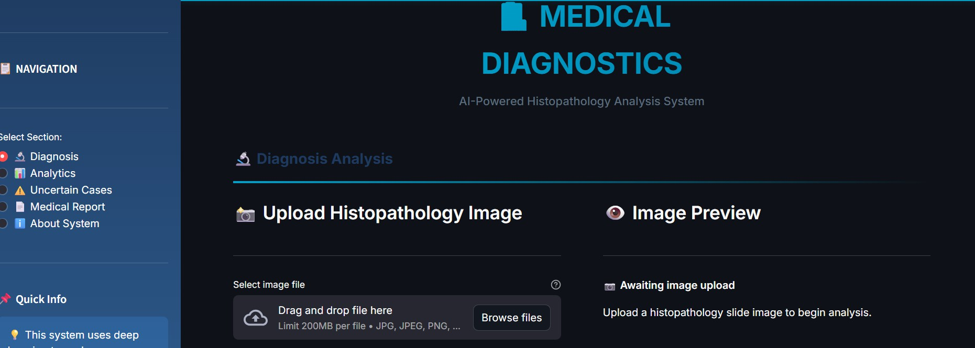

Figure 6.1 – Analysis Settings and Image Upload Interface

Image Upload Screen
This screen allows users to upload histopathological images for analysis. The system supports common image formats such as JPG, JPEG, and PNG. The interface includes a file upload section where users can select an image from their local device.
After selecting the image, the user can click the “Predict” or “Analyze” button to initiate the classification process. The system then performs preprocessing steps such as resizing and normalization to prepare the image for model input.
The interface is designed to be simple and efficient, allowing users with minimal technical knowledge to upload images and perform analysis easily.

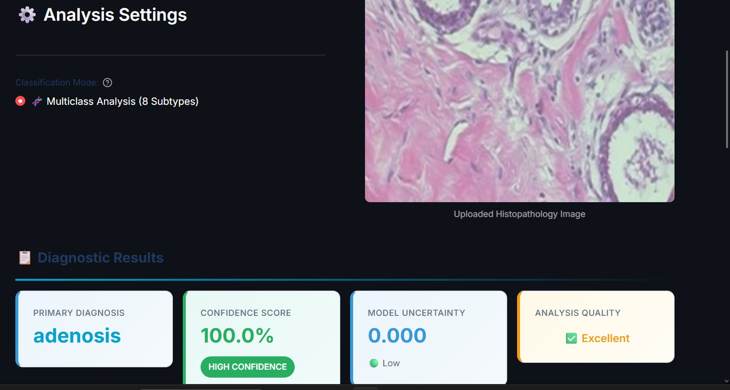

Figure 6.2– Classification Probability Distribution and Detailed Result

Feature Processing and Visualization Screen
This screen represents the internal processing of the uploaded image. The system passes the image through multiple convolutional neural networks—EfficientNetB0, ResNet50, and VGG16—to extract deep features.
The extracted features are combined using a feature fusion mechanism and refined using a Squeeze-and-Excitation (SE) attention block. Additionally, the system generates Grad- CAM visualizations that highlight the important regions of the image contributing to the prediction.
The interface displays:
Original input image Grad-CAM heatmap Overlay visualization
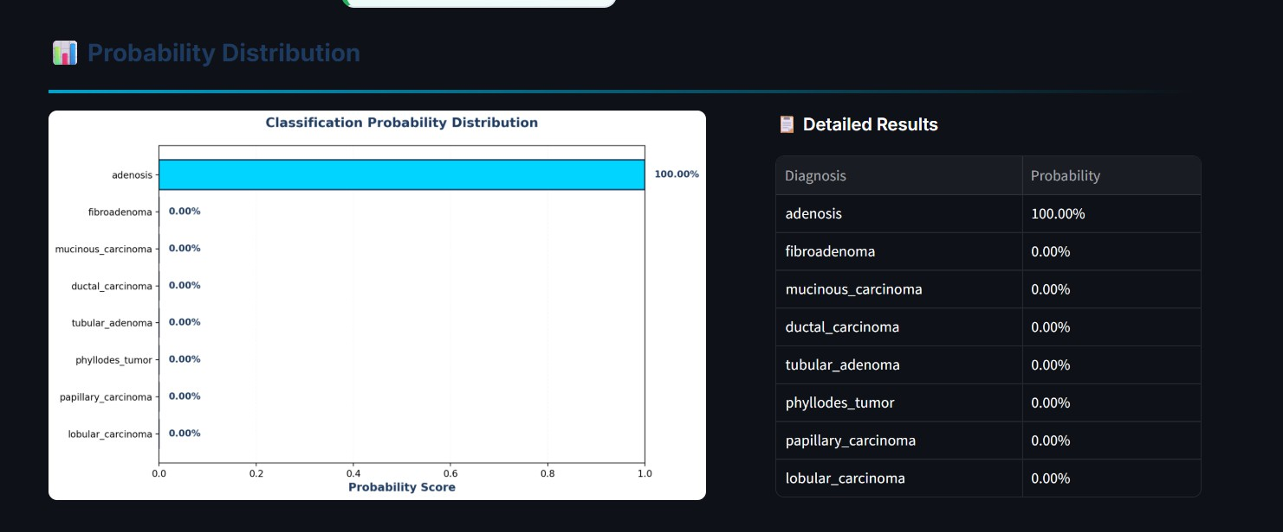
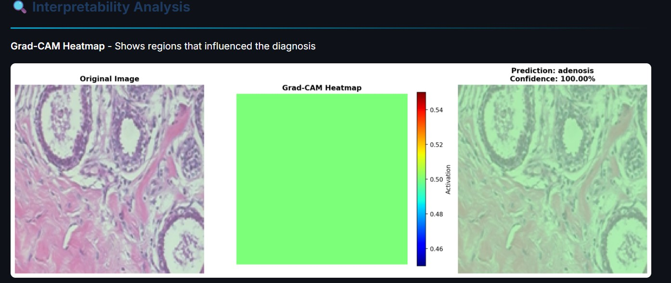

Figure 6.3 – Grad-CAM Interpretability Analysis

Prediction Screen
This screen displays the classification results generated by the system. After processing the image, the trained model predicts whether the tissue is benign or malignant. If multiclass classification is selected, the system also predicts the specific cancer subtype.
The output includes:
Predicted class label (Benign / Malignant or subtype) Confidence score of prediction
Probability distribution across all classes
Entropy value indicating prediction uncertainty
The results are presented in a clear and structured format, allowing users to easily interpret the diagnosis.
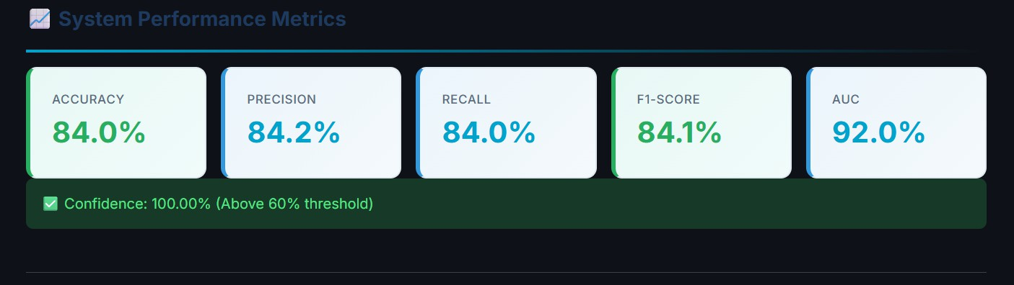
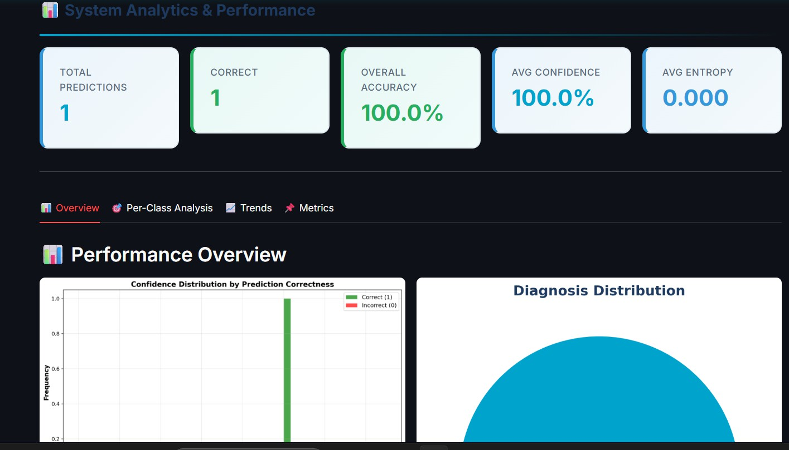

Figure 6.4 – System Performance Metrics Display

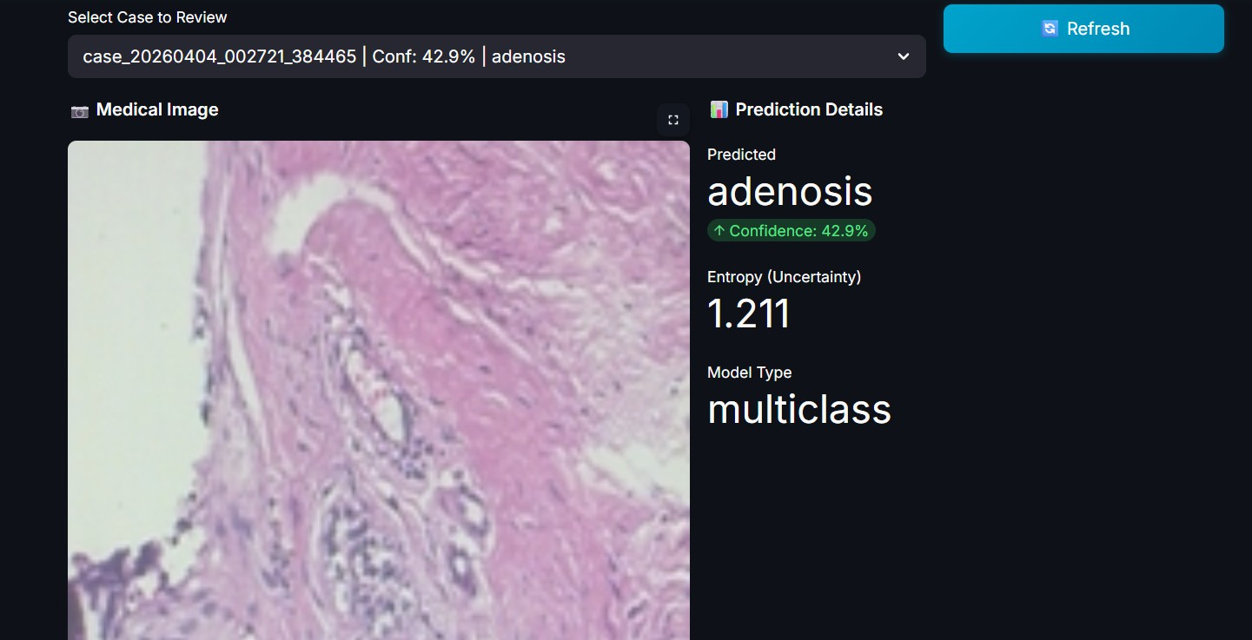

Figure 6.5– Uncertain Case Review Interface

58

Results and Analysis Screen
This screen provides a detailed breakdown of the prediction results. It includes:

Final classification result
Confidence score and probability distribution
Grad-CAM visualization highlighting tumor regions Summary of model predictions
The system may also display additional analytics such as charts or graphs representing class probabilities and confidence levels. If the prediction confidence is low, the case is flagged as uncertain and stored for further review through the Active Learning module.
The design of this screen focuses on clarity, interpretability, and usability, ensuring that users can easily understand the output generated by the system.

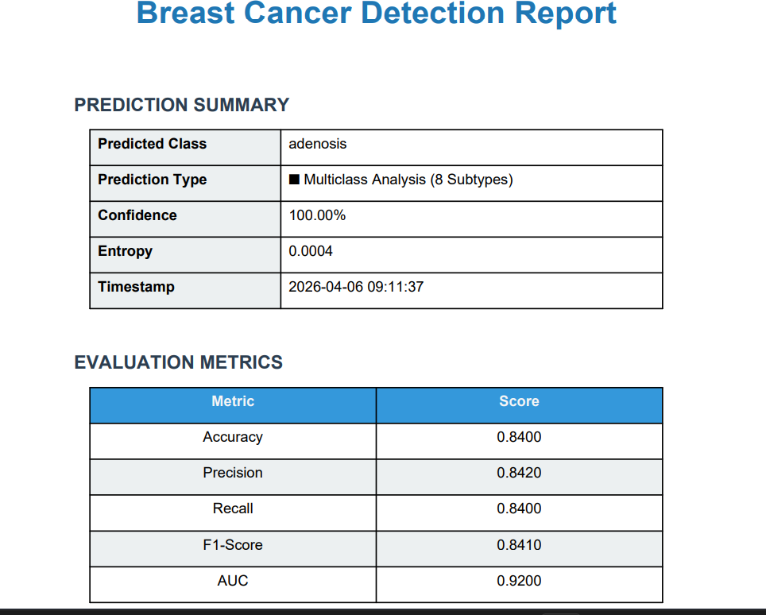

Figure 6.6 – Generated Prediction Report



Figure 6.7 – System Overview Dashboard

TESTING METHODOLOGY

Types of Testing Methodologies
Testing is a critical phase in the development of the Breast Cancer Detection System to ensure accuracy, reliability, efficiency, and usability. Since the system processes histopathological images and performs classification using deep learning models, testing focuses on validating image preprocessing, feature extraction, model prediction accuracy, and overall system integration.
The system processes medical images, extracts deep features using multiple CNN backbones, and classifies them into benign or malignant categories and further into eight subtypes. Therefore, testing ensures correctness at both the model and application levels.

Unit Testing
Unit testing was performed on individual components of the system to verify their correctness before integration.
Each module such as data loading, preprocessing, feature extraction, model prediction, Grad-CAM visualization, and frontend interaction was tested independently.
Examples include:
The image upload module was tested to ensure the system accepts valid formats such as JPG, PNG, and JPEG and rejects invalid formats.
The preprocessing module was tested to verify correct resizing (160×160), normalization, and image conversion.
The feature extraction module was tested to confirm that all three backbone models (EfficientNetB0, ResNet50, VGG16) generate correct feature vectors.
The feature caching module was tested to ensure .npy files are correctly saved and loaded.
The classification model was tested using sample inputs to verify correct prediction outputs and probability scores.
The Grad-CAM module was tested to ensure proper heatmap generation highlighting relevant regions.

System Testing
System testing was conducted to validate the complete workflow of the application. This ensures that all modules work together correctly in real-world scenarios.
Examples include:

Uploading a histopathology image and verifying the full pipeline: preprocessing → feature extraction → prediction → result display.
Testing both binary classification (Benign/Malignant) and multiclass classification (8 subtypes).
Verifying that confidence scores and entropy values are correctly displayed.
Ensuring that low-confidence predictions are stored in the uncertain_cases module. Testing the Streamlit interface for correct navigation and functionality.
This phase confirmed that the system performs end-to-end classification accurately and reliably.

Performance Testing
Performance testing was conducted to evaluate system speed, efficiency, and responsiveness.
Key factors evaluated include:

Time required for image preprocessing and prediction Model inference speed
Feature extraction and caching efficiency CPU and memory utilization
Results:
Feature caching reduced training time from over 8 hours to approximately 23 minutes Prediction time per image is within a few seconds
The system handles multiple inputs efficiently without performance degradation

Security Testing
Security testing ensures safe handling of medical image data and system integrity. The following aspects were tested:

Validation of uploaded image formats to prevent malicious files Secure storage of uncertain cases and prediction outputs
Prevention of unauthorized file access
Safe handling of user-uploaded images within the application
These tests ensure that the system maintains data integrity and prevents misuse.

User Acceptance Testing (UAT)
User Acceptance Testing was performed to evaluate usability and practical functionality.
Users interacted with the system and provided feedback on:
Ease of image upload and prediction
Clarity of results (class, confidence score, entropy) Visualization quality (Grad-CAM heatmaps, charts) Overall user interface design and navigation
Outcome:
The system was found to be user-friendly, responsive, and informative for medical image analysis.

Validation and Accuracy Testing
Validation testing ensures that the model produces reliable and clinically meaningful predictions.
The system performance was evaluated using:
Accuracy – Correct predictions over total predictions Precision – Correct positive predictions
Recall (Sensitivity) – Ability to detect malignant cases F1-Score – Balance between precision and recall
AUC-ROC – Model discrimination capability Results:
Binary classification accuracy: 95.11%
Multiclass classification accuracy: 80.79%
Expected improvement after augmentation: 97%+ (binary), 90%+ (multiclass) Incorrect predictions were analyzed to improve training and model generalization.

TABLE 7.1 Test Cases for Personality Classification System
TEST CASE

Invalid Image Upload

Image Upload

Preprocessing

Feature Extraction

Classification

Grad-CAM Visualization

Uncertainty Detection

Performance

Accuracy
INPUT

Unsupported format (.txt/.pdf)

Valid histopathology image

Input image

Image with tissue

Test dataset image

Input image

Low confidence image

Multiple inputs

Test dataset
EXPECTED ACTION

System should reject file

System should accept image

Resize & normalize image

Extract CNN features

Predict class with confidence

Generate heatmap

Store in uncertain_cases

Process within few seconds

Accuracy above threshold
ACTUAL ACTION

Error message displayed

Image uploaded successfully

Process completed correctly

Features generated correctly

Prediction generated

Heatmap displayed correctly

Stored successfully

Avg response
~2–3 sec

Binary: 95.11%
STATUS

PASSED

PASSED

PASSED

PASSED

PASSED

PASSED

PASSED

PASSED

PASSED

CONCLUSION & FUTURE ENHANCEMENTS

Conclusion

The Breast Cancer Detection System developed in this project presents an effective and intelligent solution for histopathological image classification using deep learning techniques. By leveraging a Feature Fusion Ensemble Architecture that combines EfficientNetB0, ResNet50, and VGG16, the system successfully captures diverse and complementary feature representations, leading to improved classification performance compared to single-model approaches.
The integration of a Squeeze-and-Excitation (SE) attention mechanism further enhances the model’s ability to focus on the most relevant features, improving fine-grained classification of cancer subtypes. Additionally, the implementation of a feature caching pipeline significantly reduces training time from several hours to approximately 23 minutes, making the system efficient and practical even on standard CPU hardware.
The system achieves strong performance with 95.11% accuracy in binary classification and 80.79% accuracy in multiclass classification, demonstrating its capability in distinguishing between benign and malignant tissues as well as identifying specific cancer subtypes. The inclusion of Active Learning with entropy-based uncertainty detection allows the system to continuously improve by identifying low-confidence predictions for expert review.
Furthermore, the integration of Grad-CAM visualization provides interpretability by highlighting the regions of the image that influence model decisions, which is crucial for clinical acceptance. The Streamlit-based web application enables an end-to-end workflow, allowing users to upload images, obtain predictions, visualize results, and generate reports in a user-friendly environment.
Overall, this project demonstrates the potential of artificial intelligence in assisting medical diagnosis, reducing workload for pathologists, and improving the speed and consistency of breast cancer detection.

Future Work

Although the current system achieves promising results, several enhancements can further improve its accuracy, scalability, and real-world applicability.

Advanced Deep Learning Models
Future improvements can include the integration of more advanced architectures such as Vision Transformers (ViT), Swin Transformers, or hybrid CNN-transformer models. These models can capture global contextual information more effectively and improve classification performance, especially for complex histopathological patterns.

Larger and More Diverse Datasets
The current system is trained on the BreaKHis dataset from a single source. Expanding the dataset to include images from different institutions, staining protocols, and imaging devices will improve generalization and robustness. Incorporating larger and more diverse datasets such as TCGA or CAMELYON can enhance real-world performance.

Whole Slide Image (WSI) Integration
The system currently processes small image patches (160×160 pixels). Future work can extend the system to handle Whole Slide Images (WSI) by implementing patch extraction and aggregation techniques, enabling full-slide clinical analysis.

Real-Time Clinical Deployment
The system can be enhanced for real-time deployment in clinical environments. Optimizing inference speed and integrating with hospital information systems can enable rapid diagnosis support during routine pathology workflows.

Enhanced Active Learning Automation
Future versions can automate the active learning loop by triggering model retraining after accumulating a sufficient number of reviewed uncertain cases. This will enable continuous self-improvement with minimal human intervention.

Multimodal Medical Data Integration
The system can be extended to incorporate additional data sources such as patient clinical records, genetic data, or radiology images. Combining multiple modalities can improve diagnostic accuracy and provide more comprehensive insights.

Mobile and Cross-Platform Deployment

Deploying the system as a mobile or cloud-based application can increase accessibility for healthcare professionals. Cross-platform support will allow usage on smartphones, tablets, and remote systems, especially in rural or resource-limited areas.

Regulatory and Clinical Validation
Future work should include clinical trials and validation under real-world conditions. Ensuring compliance with healthcare standards and regulations (such as HIPAA) will be essential for practical deployment in medical environments.

REFERENCES
- Spanhol, F. A., Oliveira, L. S., Petitjean, C., & Heutte, L. (2016). A dataset for breast cancer histopathological image classification. IEEE Transactions on Biomedical Engineering, 63(7), 1455-1462.
- Bardou, D., Zhang, K., & Ahmad, S. M. (2018). Classification of breast cancer based on histology images using convolutional neural networks. IEEE Access, 6, 24680-24693.
- Han, Z., Wei, B., Zheng, Y., Yin, Y., Li, K., & Li, S. (2017). Breast cancer multi- classification from histopathological images with structured deep learning model. Scientific Reports, 7(1), 1-10.
- Hu, J., Shen, L., & Sun, G. (2018). Squeeze-and-excitation networks. Proceedings of the IEEE Conference on Computer Vision and Pattern Recognition, 7132-7141.
- Selvaraju, R. R., Cogswell, M., Das, A., Vedantam, R., Parikh, D., & Batra, D. (2017). Grad-CAM: Visual explanations from deep networks via gradient-based localization. Proceedings of the IEEE International Conference on Computer Vision, 618-626.
- He, K., Zhang, X., Ren, S., & Sun, J. (2016). Deep residual learning for image recognition. Proceedings of the IEEE Conference on Computer Vision and Pattern Recognition, 770-778.
- Tan, M., & Le, Q. (2019). EfficientNet: Rethinking model scaling for convolutional neural networks. International Conference on Machine Learning, 6105-6114.
- Simonyan, K., & Zisserman, A. (2014). Very deep convolutional networks for large-scale image recognition. International Conference on Learning Representations.
- Budd, S., Robinson, E. C., & Kainz, B. (2021). A survey on active learning and human-in- the-loop deep learning for medical image analysis. Medical Image Analysis, 71, 102062.
- Bayramoglu, N., Kannala, J., & Heikkila, J. (2016). Deep learning for magnification independent breast cancer histopathology image classification. Proceedings of the International Conference on Pattern Recognition, 2440-2445.
- Nazeri, K., Aminpour, A., & Ebrahimi, M. (2018). Two-stage convolutional neural network for breast cancer histology image classification. Image Analysis and Recognition. Springer, 717-726.

